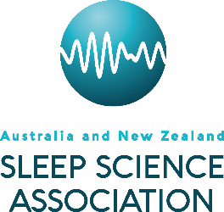
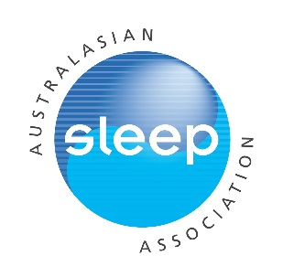
Helen Bearpark Scholarship
Applicant name:
Contact Details:
Email:
Phone:
Current institution:
Proposed overseas host institution:
Title of proposed project:
Field of study (e.g. paediatrics, circadian, insomnia, sleep apnoea etc.):
Note: All applications must be submitted online
This template may be used to prepare the application before submitting online.
Submission instructions:
In addition to completing the online application, you will need to submit a copy of your CV (you must use the CV template provided. Download) and a brief letter of acceptance from your proposed supervisor/host. Both documents will need to be in PDF format.

Details to include in letter of acceptance (as appropriate):
-statement of intent to fully supervise the applicant
-reality of anticipated outcome and timetable
-availability of resources
-evidence of recent research achievements within sponsoring/host department
Applications will be judged on:
-Quality of proposed work (30%)
-Track record and potential of applicant relative to opportunity (30%)
-Quality of sponsoring institution (20%)
-Likelihood of enduring exchange and benefit to sleep research/sleep medicine (20%)
-Length of ASA/ANZSSA membership may be taken into consideration.

Only full applications with all requested materials submitted prior to the closing date will be considered.

Brief description of the project for which the funds will be used (3000 characters max, including spaces)

References (3000 characters max, including spaces)

Brief overview of host institution (2000 characters max, including spaces)

Brief description of how this travel will benefit the applicant’s career in sleep research/ medicine &/or the applicant’s institution, & sleep community in general (2000 characters max, including spaces)

Timetable-specify proposed departure date, commencement date, expected duration of scholarship & hours per/week if not full-time (2000 characters max, including spaces)

Brief budget with justification including description of how funds will be used (include other sources of funding support if applicable) (2000 characters max, including spaces)

